Meghan Schmalzbauer
Rossi
Art II
2 November 2016
Claude Monet
Claude Monet was born in November of 1890 in Paris, France to Claude and Louise Monet. His mother was a singer, and his father ran a family grocery business and hoped that he would one day join him; however, Monet wanted to be an artist. Monet started his path to becoming an artist in secondary school, where locals knew him for his charcoal pieces. It was during this time that he met Jacques-Louis David, who taught him how to draw and use oil paints. As he continued to grow as an artist, and eventually became the founder of what will later be known as the impressionist movement.
Impressionism is known as the movement that started in the 19th-century. It is characterized by broken brush strokes that appear streaky and unblended on the canvas. Impressionism emphasizes the depiction of light and creates movement in ordinary subjects by using unusual angles. This movement was started in France, focused mainly in Paris, and was most prominent during the 1870s and 1880s. Impressionists ignored the “rules” of painting that were set in place at the time and allowed their brushes to work freely. Their work was focused on capturing moments instead of studio-based work, and would therefore mostly work outdoors.
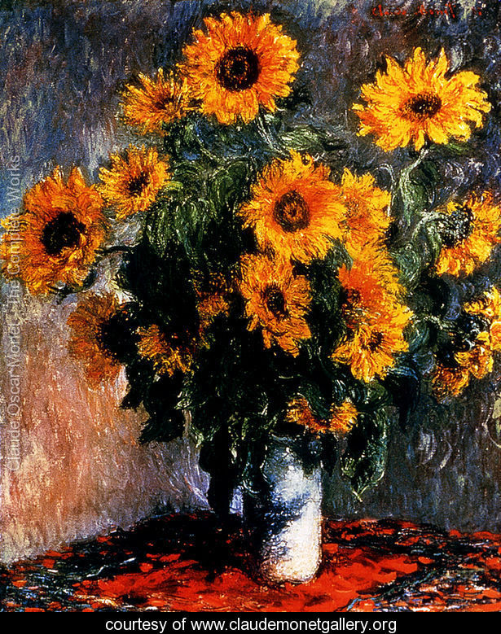
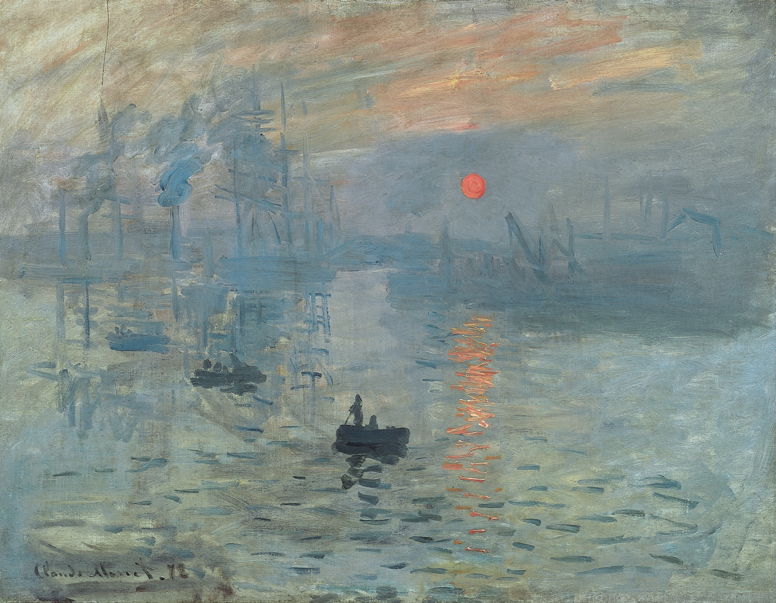
Focusing back on Monet as one of the founders of Impressionism, he has many famous works. For example, his painting Sunrise (1872) was created by using oil paints on canvas. The painting itself would have been extremely dull if he had chosen to paint this in a studio. The grey-green of the painting as a whole would usually cause a painting like this to fall flat; however, by using impressionist techniques, Monet was able to push the highlights and shadows to create more depth. The orange, yellow, and white that he added to the dull sky pulls the eye upwards to push the boats in the background backwards. The highlights on the water, especially under the sun, have the same effect.
Although a lot of Monet’s work was of landscapes, he did have quite a few other types of paintings. The second painting I included was a still life of sunflowers. Monet uses his broken brush strokes to create texture along with value along the petals and the stems of the flowers in this piece. The shadows of the green stems are pushed so that they are almost black against the bright yellow highlights of the sunflowers. Even the background incorporates the highlights and shadows of natural light hitting the vase. By incorporating natural light and choppy brush strokes, he is demonstrating a few of the many aspects of impressionism.

Bibliography
"Claude Oscar Monet - The Complete Works." Claude Oscar Monet - The Complete Works. N.p., n.d. Web. 02 Nov. 2016.
"Claude Monet." Wikipedia. Wikimedia Foundation, n.d. Web. 02 Nov. 2016.
"Impressionism." Wikipedia. Wikimedia Foundation, n.d. Web. 02 Nov. 2016.

